ENGR421 – HW6 REPORT

BERK BAHADIR BAHCETEPE

0071533

For this homework, I started by assigning the first 1000 images to the training set and the remaining 4000 images to the test set. After, I implemented an one-versus-all support algorithm using binary classification to a multiclass case. In order to do that, I implemented 5 SVM binary classification algorithms for each class. In each SVM, I selected one class to be 1 and the rest of the classes to be -1 and since there are 5 classes, I applied 5 different SVMs. With the help of the binary classification code in Lab 8, my code learned the parameters for each cases using the training set and when a new test data point arrives, I calculated the gscore for each cases and picked the maximum one as the prediction. I obtained the following confusion matrices for training set and test set respectively:

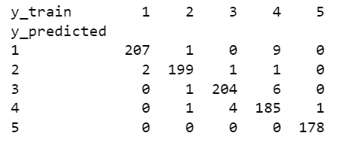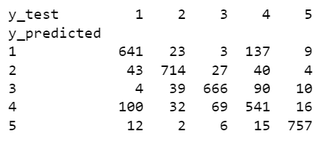

After I did not change the s variable however, I calculated the accuracy of my model for different values of C such as 0.1, 1, 10, 100, 1000. In conclusion I obtained the accuracy graph for the training and test set as such:

